THE CORRELATION BETWEEN STUDENT’S ATTITUDE IN ENGLISH LESSON AND THEIR ACHIEVEMENT AT MAS TI KOTO TINGGI PANDAI SIKEK
THESIS
Submitted As A Fulfillment of The Requirement To Obtain Strata One (S1) Degree On English Educational Department

Written By :
Lainul Humaira
2314.118

Advisor I

Hilma Pami Putri, M.Pd
NIP . 198605112015032003

ENGLISH EDUCATION DEPARTMENT
FACULTY OF TARBIYAH AND TEACHER TRAINING
STATE ISLAMIC INSTITUTE BUKITTINGGI

PENGESAHAN TIM PENGUJI
Skripsi yang berjudul The Correlation Between Student’s Attitude In English Lesson And Their Achievement at MAS TI Koto Tinggi Pandai Sikek yang disusun oleh Lainul Humaira dan NIM 2314118, telah diuji dalam sidang Munaqasyah Program Studi S1 Pendidikan Bahasa Inggris (PBI) pada hari Jumat, tanggal 14 Agustus 2020. Dan telah berhasil dipertahankan di hadapan Dewan Penguji dan diterima sebagai persyaratan yang diperlukan untuk memperoleh gelar Sarjana pada Program Studi S1 Pendidikan Bahasa Inggris.
Bukittinggi, Agustus 2020

TIM PENGUJI
Ketua Sekretaris

Hilma Pami Putri, M.Pd Eliza, SS., M.Pd
NIP.198605112015032003 NIP.197311292003122003
Anggota
Penguji Utama Penguji Utama

Eliza, SS., M.Pd Drs. Genta Sakti, M.A
NIP.197311292003122003 NIP . 196410101994072001

Penguji Pendamping

Hilma Pami Putri, M.Pd
NIP.198605112015032003

Mengetahui:
Dekan Fakultas Tarbiyah dan Ilmu Keguruan Institut Agama Islam Negeri (IAIN) Bukitinggi

Dr. Zulfani Sesmiarni, M.Pd
NIP. 198109232005012005

ABSTRACT
Lainul Humaira, 2314.118, “The correlation between student’s attitude in English Lesson and their achievement at second grade in MAS TI Koto Tinggi Pandai Sikek”.
In this study the researcher found several problems that faced by students of class XI in MAS TI koto Tinggi. The problems were: firstly, there was negative attitude of students at secondly grade toward English language learning. Secondly, the outcome of students in English language learning was varied, such as high, moderate, and low. Thirdly, it was unknown whether there was a relationship between students ' attitudes in learning and their learning outcome. This study aimed to find out: (1) The category of student learning attitudes towards learning English (positive or negative), (2) To know the outcome of students in learning English, (3) To know whether there was a relationship between learning attitudes toward the student's value in learning English.
The method that used in this research was descriptive quantitative. The Sample in this study was all the grade 11 students at MTI Koto Tinggi in academic year of 2019/2020. Sampling technique in this research was saturation sampling. The data collection techniques in this study were questionnaire and documentation. Data analysis technique was using SPSS version 20 program.
There were three findings in this study. The first was the student's attitude towards English language learning, the results showed that most of the XI-grade students ' attitudes towards learning English were positive with the value of 3.67. Second the student score in learning English, The average score which obtained by students in English: Under the KKM of 20%, the KKM limit of 10%, above the KKM to 70%, so it can be concluded that the value of students towards English language learning was in high category. Third the relationship between students ' learning attitudes toward the value gained in English learning, the results were known about correlation was the R-Count (0643) was greater than R-table (0361). Based on findings above, it can be concluded that there was a relationship between student learning attitudes toward student grades.
Keywords: Attitude, Students’ Grade in English, Correlation

ABSTRAK
Lainul Humaira, 2314.118, “The correlation between student’s attitude in English Lesson and their achievement at second grade in MAS TI Koto Tinggi Pandai Sikek”.
Pada penelitian ini ditemukan beberapa masalah yang dihadapi oleh siswa kelas XI di MAS TI koto Tinggi. Permasalahan tersebut ialah, pertama adanya sikapnegatif siswa terhadap pembelajaran bahasa inggris. Kedua, hasil pencapain siswa dalam pembelajaran bahasa inggris beragam, seperti tinggi, sedang, dan rendah. Ketiga, tidak diketahui apakah ada hubungan antara sikap siswa dalam pembelajaran dan hasil pencapain belajar mereka.Penelitian ini bertujuan untuk mengetahui: (1) kategori sikap belajar siswa terhadap belajar Bahasa Inggris (positif atau negatif), (2) mengetahui hasil pencapain siswa dalam bahasa inggris , (3) mengetahui apakah ada hubungan antara sikap belajar terhadap nilai siswa dalam belajar bahasa inggris.
Metode yang digunakan adalah descriptive kuantitative. Sample dalam penelitian ini adalah seluruh siswa kelas 11 di MTI Koto Tinggi tahun pelajaran 2019/2020. Teknik pengambilan sampel menggunakan teknik sampling jenuh. Teknik pengumpulan data menggunakan angket dan dokumentasi. Teknik analisis data menggunakan program SPSS versi 20.
Ada 3 penemuan yang ditemukan dalam penelitian ini, pertama yaitu sikap siswa terhadap pembelajaran bahasa inggris. Hasil penelitian menunjukkan bahwa sebagian besar sikap siswa kelas XI terhadap pembelajaran bahasa inggris berkategori positif dengan nilai 3.67.Kedua, kategori nilai siswa dalam pembelajaran bahasa inggris, Rata – rata nilai yang di peroleh siswa dalam mata pelajaran bahasa inggris : dibawah KKM sebanyak 20%, batas KKM sebanyak 10%, Diatas KKM sebanayk 70%, jadi dapat disimpulkan bahwa nilai siswa terhadap pembelajaran bahasa inggris berkatogori tinggi. Ketiga, hubungan antara sikap belajar siswa terhadap nilai yang diperoleh dalam pembelajaran bahasa inggris. Hasil analisis data diketahui bahwa r hitung 0.643 lebih besar dari r-table 0.361. kesimpulannya diketahui bahwa ada hubungan antara sikap belajar siswa terhadap nilai siswa.
Kata kunci:Nilai Bahasa Inggris, Sikap, Hubungan

ACKNOWLEDGEMENT


Alhamdulillahirabbil’alamin, in the name of Allah the Almighty, the researcher thanks to Allah SWT, who guide the heart, the mind, and give hidayah to researcher in completing this thesis under the title “The correlation between student’s attitude in English Lesson and their achievement at second grade in MAS TI Koto Tinggi Pandai Sikek”. Shalawat and Salam to Prophet Muhammad SAW who is the best leader to be obey and the best apostle to convince.
The researcher would like to express to the people who give their knowledge, contributions, and help to the researcher to conducting this thesis:
- Dr. Ridha Ahida, M. Hum, as the Rector of IAIN Bukittinggi and also her first, second, and third assistant.
- Dr. Zulfani sesmiarni, M.Pd, as the dean of Teachers Training and Tarbiyah faculty in IAIN Bukittinggi and also her first, second, and third assistant.
- Loli safitri, M.Pd, as the head of English Education Departement IAIN Bukittinggi
- Hilma Pami Putri M.Pd as her advisors for their understanding, guidance, time, patient, suggestion, critics, and correction in complementing this thesis.
- All her family beloved father and mother, her sister and her grandmother’s and who never stop giving love, prays, supports, motivation and advices
- The librarians of IAIN Bukittinggi who have sincery helped and allowed the researcher in collecting the references.
- All of the lecturers who have given their knowledge, ideas, and contributions during her study and helped to the completion of her thesis.
- Sendu Ardila S.Pd as the English teacher and the students of MAS TI Koto Tinggi Pandai Sikek especially for XI grade students for their helps, supports, and helped to do this research.
The researcher hopes Allah SWT always blesses the people who have helped the researcher and also for all that can be not mentioned one by one. Hence, the suggestions, valuable critics, and the meaningful advices from the reader are highly appreciated to make this thesis become more meaningful
Bukittinggi, Juli 2020

The Researcher

.

TABLE OF CONTENT

ABSTRAK i
ABSTRACT ii
ACKNOWLEDGEMENT iii
TABLE OF CONTENTS v
LIST OF TABLES vii
LIST OF APPENDICES viii

CHAPTER I INTRODUCTION
- Background of the Problem 1
- Research of the Problem 4
- Purpose of the Research 4
- Research Hypothesis 5
- Significance of the study 5
- Scope and Limitation of the Research 6
- Definition of Key Term 6

CHAPTER II REVIEW OF RELATED LITTERATURE
- Review of Related Theories 7
- Attitude 7
- English Language Learning 14
- Attitude in Learning English 15
- Students’ Achievment 19
- Correlation Between Students’ Atittude and Achievment 21
- Review of Related Studies 21
CHAPTER III RESEARCH METHODS
- Design of the Research 23
- Population and Sample 24
- Instrumentation 26
- Technique of Data Collection 28
- Hypothesis Testing 33
CHAPTER IV FINDINGS AND DISCUSSIONS
- Findings 35
- Discussion 47
CHAPTER V CONCLUSIONS AND SUGGESTIONS
- Conclusions 49
- Suggestions 50
REFFERENCES 52
APPENDICES 54

LIST OF TABLE
3.1 Correlation Betwen Variables 24
3.2 Population of the research 25
3.3 The scoring system of attitudes toward English Questionnaire 30
3.4 Attitude indicator grid 30
3.5 The classification system for attitude judgement 33
3.6 The Interpretation of the Correlation Coefficient 34
4.1 English Score Semester 2 class XI 38
4.2 Students’ Score Percentage 39
4.3 Calculate of students’ Score Percentage 39
4.4 Validity Test 41
4.5 Reability Test 42
4.6 Reability Statistic 42
4.7 Test of Normality 43
4.8 Test of Linearity 44
4.9 Test of Correlation 46

LIST OF APPENDICES
Appendix 2 : Questioner 54
Appendix 2 : The scoring of Student’s Attitude toward Learning English 57
Appendix 3 : The Average of Student’s Attitude Toward Learning English 58
Appendix 4 : Test of Validity 59
Appendix 5 : Test of Normality 60
Appendix 6 : Test of Linearity 63
Appendix 7 : Surat Permohonan Izin Penelitian 65
Appendix 8 : Surat Izin Penelitian dari Kesbangpol 66
Appendix 9 : Surat Permohonan Validasi 67
Appendix 10 : Surat Pernyataan telah Validasi 1 68
Appendix 11 : Surat Pernyataan telah Validasi 2 69
Appendix 11 : Surat SK Pembimbing 70
Appendix 12 : Nilai Rafor Bahasa Inggris siswa MAS TI Koto tinggi 71

CHAPTER I
INTRODUCTION

- BACKGROUND OF THE PROBLEM
Education is the most important element that can elevate a person's degree. According to Sagala states that education is a conscious effort and aims to develop human quality.That is, the higher the education of one, the more experience and knowledge gained. The process of education is certainly inseparable with all efforts to be done to develop quality human resources. Qualified human resources can be seen from the increasing quality of education.
The government has made the efforts to increase the quality of education in Indonesia. The purpose of the increasing education is to develop the potential of students to become human beings, noble, healthy, knowledgeable, capable, creative, independent and can compete with the others in the world. To make it happen it takes a fairly basic change in the national education system that is viewed by various parties unable to provide provision and cannot prepare learners to compete with other nations of the world. These fundamental changes relate to the curriculum that Itself demands changes to other components of education.
The Government makes and designs the curriculum for the school in Indonesia. Schools in Indonesia have many standards and several compulsory subjects that must pass by the students. English is one of compulsory subject for junior and senior high school. Depdiknas RI states that there are three standard objective of English language has become the part of compulsory subject in senior high school, as follow : The first, developing communicative competence both in oral and written in order to reach the level of information literacy. Second, the students have to raise their awareness of the English as a global communication in order to compete with the other countries. Third, develop student’s comprehension about the relation between language and culture.
From the explanation above, it can know that English is important for students because it is the international language that they can use to communicate with the others. English is compulsory subject for students in senior high school, which they have to proficiency and understand about that.
Ironically, there are still many students do not have ability to proficiency the English language. According to Aceng, he states that the students do not use English as a foreign language to communicate with others event they have learnt in the school. As addition, English proficiency index says that Indonesian students’ proficiency is still low and they are still weak in using English language. Based on definition above, it can be known that the Indonesian students are lack in English learning.
The students lack of English have caused by several factors. According to Shams in aceng, there are various factors that influence the learning context in English proficiency as foreign language such as motivation, anxiety aptitudes, learning achievement, age, personalities, intelligence, attitude, etc. attitude is the important factor that can influence students proficiency in English language.
Suryabrata in Aceng claims that the factor can affecting student achievement is attitude. Attitude is something that is learned, and attitude determines how individuals react to the situation and determine what people look for in life.Attitude is closely related to learning because attitudes are internal factors that can affect learning.
Gowhary says that attitude is crucial in language, restoration destruction. Syukur in aceng states that attitudes can influence how individuals approach many situations in life, including foreign language learning. In addition Dalvid and Clerk claim if the people who have positive attitudes in learning language, they are more likely to learn it well. Base on definition above it can conclude that student’s attitude can affected the achievement of learning English.
Based on preliminary research at 27th November 2019 in MAS TI Koto Tinggi Pandai Sikek by interviewing English teacher to know about the student’s achievement in learning English, the researcher finds that there are many kinds of the students’ levels in their achievements and the factor affected itself. The first is the student who has a positive attitude in learning English can get good grade in their achievements. The positive attitudes such as keep intention while learning activity, interest in learning English, always do exercise. Second, the students who have negative attitude while learning English get low grade. The negative acts are the students do not have intention in learning, do not doing their exercise and do not enter in class room. From the reasons above, the researcher interest to find out if the students’ low grade in MTI Koto Tinggi Pandai Sikek has related to the lack of the students in learning English. Through the reasons above, the researcher decides this research about the correlation between student’s attitude in English Lesson and their achievement at second grade in MAS TI Koto Tinggi Pandai Sikek.
- RESEARCH PROBLEMS
Based on the background of the problem, this research identified the following problems , they are :
- How was the students’ attitude in English learning of second grade at MAS TI Koto Tinggi
- How was the students’ English achievement of second grade at MAS TI Koto Tinggi Pandai Sikek.
- Was there any correlation between students’ attitude and their achievement in English
- PURPOSE OF THE RESEARCH
Based on the problems above, the aimed of the study can be stated, as follow:
- To know the students attitude in English of second grade students at MAS TI Koto Tinggi Pandai Sikek.
- To know the students English achievement of second grade students at MASTI Koto Tinggi Pandai Sikek.
- To know whether there was any correlation between students’ attitude in English and their English achievement.
- RESEARCH HYPOTHESIS
There are two kinds of hypothesis, they are alternative and null hypothesis:
- Alternative Hypothesis(Ha)
There is correlation between students’ attitude and their achievement of English
- Null Hypothesis(Ho)
There is no correlation between students’ attitude and their achievement of English.
- SIGNIFICANCE OF THE STUDY
The results of the study are expected to bring benefit and advantages for some side. The first is for the student. In the study, students need to understand attitude to improve the quality and to get good result in learning English language.
Second, for the teachers, teachers can pay attention to the knowledge of students’ psychology; especially the attitudes will be very helpful in dealing with their students. It is expected that teachers are able to arrange a fun learning strategies that can be addressed properly by the students so as to obtain maximum learning results.
The last is for other researcher, it is hope that this study will be of any value to other researcher in conducting further research of the similar topic. This research may need some references that might useful.
- SCOPE AND LIMITATION OF THE RESEARCH
This study was conducted in MAS TI Koto Tinggi Pandai Sikek. The scope of this study is English and the limitation into the student’s attitudes in learning English.
- DEFINITION OF KEY TERMS
To avoid the perception and similarity concepts in interpreting the essential terms used in this research are defined as follow:
- Attitude
Attitude is a students’ reaction or judgment about the likes and dislikes of the person, event, or other aspects of the environment. It is a psychological phenomenon that is usually manifested in the form of behavior or action. This study focused to student’s attitudes in English.
- English achievement
Achievement is the result of learning activities stated inform of symbols, numbers, letters, or words that may reflect results that have been achieved by students in a given period. In this case the student achievement measured by the value of the test was given by the researcher.
CHAPTER II
REVIEWS OF RELATED TO LITERATURE

- REVIEWS OF RELATED THEORIES
This chapter presents the supporting information about theoretical framework that has relation with the topic of the research. The theoretical framework consisted of the following points: (1) Attitude, (2) English Language Learning, (3) Attitude in English Language Learning, (4) Achievement of English Learning. (5) Correlation between Students’ Attitude and their achievement in Learning.
- Attitude
Attitude is from the latin word “Aptus” which means behavior, adaptation and state and line of conduct. Louis Thurstone and Charles Osgood in Azwar say the attitude is a form of evaluation or reaction of feelings, a person's attitude towards the object is the feeling of favor or favoritism or feelings do not support (Unfavorable) to the object.According to Gerungan, the sense of the attitude can be translated with attitudes toward certain objects, which can be an attitude of vision or attitude, but the attitude is accompanied by a tendency to act according to the attitude to the object. So that attitude is always directed toward an object. That object can be people, objects, events, institutions, norms, values.

The attitude according to Dimyati is the ability to give judgment on something, which carries itself according to judgment. There is an assessment of something, resulting in an attitude of accepting, rejecting, or ignoring. Meanwhile, According to the Shah in Nurul state that the attitude is an internal symptom of the affective dimension in the form of a tendency to act or respond in a relatively permanent way to objects of people, goods, etc., both positively and negatively.Montano and Kasprzyk in Aceng say that attitude was outcome of individual beliefs and performance of behavior (behavior beliefs).
Based on definitions above, the researcher concludes that the attitude was a response about a certain feeling, though, and situation against an object that people liked or dislike. Attitude consists of two parts. First was positive attitude means good behavior that matched the values and norms in society or any situation. Second part was negative attitude, negative attitude was attitude that do not conform to the values and norms of life that apply to society or even contradict.
- Component of Attitude
There were some several components in attitude that influence the act of some object. Saifudin Azwar explains there were 3 components in attitude’s structures: Cognitive, affective and Behavioral Components. Its will be explained below:
First component was Cognitive Component, cognitive component was an individual's belief and understanding of an object through the process of viewing, hear, feel, established to belief and understanding provide information and knowledge about the object. Second component in attitude was affective, the affective component was the component that related to the individual's subjective emotional problems to something. The last one was behavioral component, this component was the tendency to behave an individual against an object that he faced. It’s meant that this component was how someone responded through that object.
Sarlito and Eko in Mahmudah also explained that attitude was a concept formed by three components that were cognitive, affective and convoltive. The first is cognitive components that contain thoughts and ideas that are related to attitude objects, for example includes assessments, beliefs, impressions, attribution, and responses attitude objects. Second, affective components are components that include person's feelings or emotions against attitude objects such as: feeling of like, dislike, happy or displeased against an object of attitude. Third, the conative component can be seen through a subject response that was an action or observable deed.
Bimo Walgito also explained to encrypt the attitude component had consisted of 3 parts: First was cognitive. It was a component that related to knowledge, views and beliefs towards object attitudes. Second was affective, which was a component that relates to a sense of delight or displeased against an object of attitude. Third was Conative, which was a component that related to the tendency to act towards the object of attitude. Attitude components can be used to assess how a person's attitude towards an object of attitude.
According to sumadisuryabrata, attitude contains three elements, namely: Cognitive element, Cognitive elements were includes knowledge and beliefs. The most important thing in this element is the evacuative, which ultimately gave direction to the attitude of a particular object. Second the affective element, this element showed the feelings that accompany the individual to behave towards an object which can be perceived by the individual in question, something fun or unpleasant. Third the contemplative element, this element encompassed the entire individual's personality to act on a specific object that was rational with the attitude.
Based on definition above, researcher concluded that the attitude component included three aspects, they are: cognitive, affective and conative components. Cognitive component was one's understanding, knowledge, views and beliefs toward object attitudes. The affective component was a feeling of pleasure or displeased against attitude objects. The conative component was the tendency to act on the object of attitude that indicated attitude intensity was the big little intensity of acting or behave someone against an object of attitude.
- Factors of Attitude
Human attitudes are not formed since mankind was born. Human attitudes are formed through a social process that occurs during his life, where individuals get information and experience. The process can take place in family, school and community environments. When the social process occurs the timbale relationship goes back between the individual and its surroundings. The interaction and relationship form the individual attitude patterns with the surrounding.
Saifudin Azwar outlines the attitude-forming factors: strong experience, the influence of others considered important, cultural influences, time media, educational institutions and religious institutions, the influence of emotional factors. It’s mean that the factor that influence attitude are from self experience and other situation.

Based on definition above, it known that there are many kinds factors that influence attitude. Sarlito and Eko also explained there are 4 forms of attitudes, they are: Classical conditioning, instrumental condition, social comparison, and the formation of an individual attitude. Each factor will be described in bellow:
Classical Conditioning, this process occurs when a stimulus or stimulation is always followed by another stimulus, so that the first stimulation will be a cue for the second stimulation. Second, Instrumental conditioning, which is when the learning process produces something enjoyable then the behavior will be repeated, but otherwise when the behavior brings bad results then the behavior will be avoided. Third social comparison, it is comparing others to check our view of the matter is true or false. Its mean that the factors that influence someone’s attitude are connected each other. Last, the formation of an individual attitude is also influenced by the interaction of the surrounding through complex processes.
Gerungan outlines the factors that influence the formation of an individual's attitude derived from internal and external factors. The internal factor of attitude forming is the selection of the objects that will be addressed by the individual, not all the objects surrounding it is addressed.. External factors in attitude were included two points that make up human attitudes, namely group interaction and communication.
First is Group interactions, when individuals are in a group will inevitably occur interactions. Each individual in the group has behavioral characteristics. These differences then provide information, or the examples of which is followed, forming attitudes. Second is Communication, by providing information on the Information can be suggestive, motivated and trusted. Information that tends to be negative directed will form a negative attitude, while motivating and enjoyable information will lead to change or the formation of a positive attitude.
Based on definitions above, it can be concluded that the formation of attitudes influenced by various factors, namely internal and external factors. Internal factors are personal experience and emotional state. The experience of an object that gives a pleasant or good impression will form a positive attitude, and less pleasant experience will form a negative attitude.
While emotional factors, more on the psychological condition of an individual, feelings of interest, delight, and feelings of need will form a positive attitude, while feelings of hate, indifference, and disbelief will form a negative attitude. While external factors are forming attitudes, it includes the influence of communication, group interactions, and cultural influences.
- English Language Learning
Learning a language has been done by humans from birth. Learning the language starts from learning the mother tongue, that which is a natural thing. The other hand, the second language has social functions in the community where it is studied (for example, as a lingua franca or other social-group language), while foreign languages are studied primarily for relationships outside the community itself.
Quirk in Tiara gives a definition of a second language as necessary for certain official, social, commercial or educational activities within their own country. Meanwhile, a foreign language is a language that used by persons for communication across frontier or with others who are not from their country. This is the opinion that the second language as a language is considered as a formal, social, trade or educational activity in their own country, and foreign language is a language that used by people to communicate between borders or with others not of their country.
According to Richard and Schmidt, a foreign language is a language which is not the native language of large number of people in a particular country or region, is not used as a medium of instruction in school, and is not widely used as a medium of communication in Government, media, etc. Foreign language is typically taught as school subjects for the purpose of communicating with foreigners or for reading printed materials in the language.
English is one foreign language that is considered important that must be mastered by the Indonesian people because English has a very strategic position, namely as a means of communication as well as a language of association among countries. English as a means of communication is used to convey ideas, thoughts, opinions, feelings, and also to respond to or create discourse in societal life. To be able to learn English well required knowledge of the characteristics of the English language itself.
Therefore, the government designed an education curriculum in Indonesia that makes English as compulsory subjects that must be mastered by the students. The purpose of English learning is to allow students to have knowledge of English that emphasizes on a language skill aspect that includes verbal and written language skills, both receptive and productive and is expected to Students are able to communicate well, so they can compete with the international community.
- Attitude in Learning English
There are several variables affecting language learning, Ellies states that attitude in learning English includes the level of learner progression, age, attitude and motivation. The study focused on the language attitude of the student as a variable in foreign language learning which is English. It is based on the consideration that the attitude of the language is one of the affective dimensions.
Attitude is one of the important factors in learning. Establishing the right attitude on the learners will be a motivating for him to increase his effort and persistence in learning to be successful. Therefore, attitude is one of the factors that should be observed and considered to improve the teaching and learning process in the classroom. In language learning, language attitudes have an influence on the motivation to learn learners. Learners who have a positive language attitude have a tendency to succeed compared to those with negative attitudes.
Attitude is always related to the feeling of an object accompanied by positive or negative feelings. People have a positive attitude towards an object of value in his view, and it will be negative to the object that it considers to be worthless and or detrimental. This attitude then underlies and pushes towards the deeds that each other relates.
However, people can only have an attitude toward things he knows. So there must be merely information on someone to be able to behave on an object. If based on that information arise positive and negative feelings towards the object and give rise to the likelihood of a certain behavior, the attitude occurs.
The positive attitude in learning is very important for a student, because if not so how students will feel happy in carrying out the learning process in the classroom. Thus the attitude of the student is said to be good, so he will like, be interested. Otherwise the attitude is said to be not good if he avoids or hostile. In the learning process is seen how students ' views or attitudes toward the learning process are directly where teachers are teaching.
Brown and Holtzman in sincerely Tu'u develop the concept of students ' attitudes in learning. They through that there were two components in attitude, namely Teacher Approval and Education Acceptance. Each will be described below:
First is Teacher Approval (TA) is related to the students ' view of the teachers, their behavior in the classroom; and the way of teachers teach. First, how do students ' view on teachers who teach in class. Second, how do students ' view on teacher behavior in classroom. Third, how do students view the way teachers teach.
There are two positive and negative views. If a person has a positive attitude in the learning process, he will be ready to help, pay attention. The other hand, if students have a negative attitude towards the learning process it will be indifferent to that learning.
Second is Education Acceptance (EA) is the acceptance and rejection of students to the objectives to be achieved; and the materials to be presented, practices, duties, and requirements set forth in the school.The attitude is important because it is based on teacher role as leader in learning process. How students ' attitudes toward the teacher's style of teaching, the material being taught, the task, and the objectives achieved will be achieved very influential in the learning and learning outcomes of the students.
Based on two components above, it can know the object of attitude of students in the learning process was as follows: first, student's view of how teachers teach in class, second, the student's view of answering the questions posed by the teacher. Third, the students' views how teacher’ behavior in the learning process. Fourth, admission of students to the purpose of the material submitted. Fifth, student acceptance of the benefits presented, Sixth, student acceptance of the duties given by the teacher, Last, student acceptance of rules imposed by teachers
A positive attitude to the English learning process is expected, but students ' attitudes are not always positive but may be negative. The attitudes of the students certainly vary there are very fond of it until very dislike, depending on the social background of the culture and the student's own experience. The attitude in the positive learning process will lead to a higher intensity of activity than a negative learning attitude.

- Students’ Achievement
Learning is a process of behavioral change based on the experience and practice. This means that the objective of the activity is a change of behavior, whether it is knowledge, skill or attitude, even covering all aspects of the organism or personal. To know if all those aspects have been achieved, then a teacher needs to make an assessment of the students’ achievement in English Learning.
Results obtained from the assessment are expressed in the form of learning outcomes. Learning outcomes are the ability that children have gained through learning activities through learning-teaching interactions. Learning results can be found through test results. From the test the results of the study are subject to the ability or level of mastery (lessons) teaching material or teaching purpose by students. The learning test results in examining the learning outcomes achieved by the students, the learning outcomes of the student's ability.
To achieve optimal learning outcomes, one is influenced by many factors. Muhibbin Syah stated that factors influencing learning outcomes can be differentiated into three types. The first is Internal Factor, second is external factor, third the learning approach. They will be described bellow:
The first one is internal factor. Which factors that comes from within the students themselves, such as: physiological aspects and psychological aspects. Physiological aspects are an aspect that concerns the existence of a student's physical condition. While psychological aspects include the level of intelligence, talents, interests, motivation and cognitive abilities of students.
Second is External factor. External Factors are the factors that come from outside students, such as social environment factor and non-social environment factor. The social environmental factors include teachers, administrative staff and classmates. While the non-social factors that includes in this are the factors that include school buildings, residential students, practical tools and others.
Third is the learning approach factor. This is the type of effort the students include and the methods used for conducting learning activities such as environmental factors, curriculum, programs, and facilities. Based on definition above, that means that the are many factors that influence the students in learning, such as students’ physical condition, social condition, and the learning activities.

- Correlation between Students’ Attitude and their achievement in Learning.
Success or not the students in learning very determined the individual factor of the student itself and environmental factors. Individual factors in the form of physical health, motivation and learning interests, students ' attitudes, the concentration of learning discipline and regularity in learning. Another factor that affects student learning outcomes in English is attitude. Attitudes determine how individuals react to the situation and determine what the individual seeks in life.
Students ' learning attitudes toward English will be tangible in the form of happy or displeased feelings. According to the law of study expressed by Thorndike something that raises a sense of delight, tends to be repeated. In a positive manner then students will tend to delight, approve, approach, pay attention and be able to use English. However, in a negative stance there are likelihoods to avoid, disapproving, hate, and avoiding certain problems.
- REVIEW OF RELATED STUDIES
Relevant research is done with the intention to avoid the design of the research findings. In addition to showing the authenticity of research that topics are researched by other researchers in the context the same. In addition to knowing past researchers, it is very assisting researchers in selecting and establishing research designs that as researchers gained an overview and comparison of the design that has been implemented.
In 2017, Aceng did his research about the correlation between students’ attitude towards English and their English proficiency of the eleventh grade students of SMAN 1 PangkalanLampam. Result of his study was the R obtain was lower than R table. It means that there is no significant correlation between students’ attitude toward their English proficiency.
Second, in 2017 M. Jainuri in his title research about Effect of Attitudes and Intelegency Level Toward Students English Achievement of First Grade at SMK Tri Bhakti Bangko Academic Year 2009/2010. The results of the analysis of experiment data showed a correlation coefficient variable X1 to Y by 0.491> r table or 0.492 > 0.468, that means that Ho was rejected and Ha was accepted. Based on his research, that known that there was significant correlation between attitude and intelligence toward mathematics achievement at Tri SMK Bhakti Bangko academic year 2009/2010.
After the researcher read and learn some of his previous scientific works, his relevance element with the research the author is doing is the same as discussing the students ' attitudes and student learning outcomes, but on research conducted by Jainuri form of his research was qualitative descriptive. While the researcher by himself did conducts correlate quantitative research. So it is obvious that the research that researcher does not duplicating on the design of previous research findings.
CHAPTER III
RESEARCH METHODS

- Design of the Research
The researcher took this research on The Correlation Between students’ Attitude towards Learning English and Students’ Achievement at MAS TI Koto Tinggi Pandai Sikek. The design of this research was a Correlation research. As described by Sukmadinata, she said that correlational research was intended to know the relationship of a variable with another variable that could expressed by the magnitude of the correlation coefficient and the significance Statistics. Based on definition above, it could be said that research was the work done by someone to prove the theory following the steps that had been set.
This research was conducted through a quantitative approach. Tanzeh explained that quantitative research was a research that basically used deductive-inductive approach, meaning that departs from a theoretical framework, the notion of experts. Its mean that quantitative research was defined as a systematic investigation by gathering quantifiable data.
As described earlier that this study had two variables. The first was Independent variable (X), which was the attitude of students to the English language subjects. Then the second variable was dependent variable (Y), namely student learning achievement. The description of the correlations between variables in this research was seen in the table below:
Table 3.1
Correlation between variables
Variable X (Independent  Variable)  Variable Y  (Dependent Variable) | Students’ attitude towards Learning English
Students’ Achievement | Students’ attitude towards Learning English

- Population and Sample
- Population
Population is the totally subject of the research. According to Arifin, population is the whole subject that wants to be researched and targeted to the generalization of research results.Then Margono states that population are objects that consist of human, thing, phenomena, event and many others.According to Sugiono, population are the generalized areas that consist of object or the subject that has certain quality and characteristic that set by the researcher to learn and take the conclusion.Based on definitions above, the researcher concluded that the populations were totality of the presumable whole grade, result for counting and measuring the research about the certain features from the whole group which was wanted to find out its features.
The population of this research was all students from eleventh grade in MAS TI Koto Tinggi Pandai Sikek that were 30 students .As shown following:
Table 3.2
Population of the research
Class | Students
XI IPS | 16
XI IAI | 14
Total | 30
Source : Tata Usaha MAS TI Koto Tinggi Pandai Sikek
- Sample
Sample is a part of population that is supposed to represent the characteristic of the population. Gay says that the sampling is selecting a number of individuals for a study which that the individuals represent the larger group from which they are selected. In addition, Margono explains that the sample is a part of the population that taken by usingin certain ways. Thus, the sample is the part of population that use in the research to find the data by selecting a number of individuals.
Arikunto says that, if the population is less than a hundred, it must be taken all as sample and it categorized as population research. However, if the population is hundred or more, it should be taken 10% to 25% or 20% to 25% from the population. The sample that took in this research was all of the population, because the population were 30.
- Instrumentation
Conducting research is essentially conducting measurements of the problems studied. To perform such measurements, a measuring instrument is required to conduct research called instruments. Sugiono explained that data collection techniques are a major step in research, because the primary purpose in research is getting data. The instruments used in this study were questionnaires and documentation.
- Questionnaire
Questionnaire is an investigation into a problem that is mostly common interest (the crowd), done by passing a list of questions in the form submitted in writing to a number of subjects To get an answer or a written response as needed sugiyono states that questionnaires are data collection techniques by giving a set of questions or written statements to respondents to answer them.
Joseph Muri devides the questionnaire into 3 parts, they are: Closed Questionnaire, which questionnaires alternative predefined answers, It means that the respondents only choose the answers between alternatives that have been provided. Second Open Questionnaire, is the questionnaire that provides an opportunity for students to express their opinions about something in questionnaire. Third Closed and open questionnaire, this questionnaire is a combination of close and open questionnaire.
The questionnaire that used in this research was closed questionnaire, it means that the students just choose the answer between alternative that have been provided. That’s means the questionnaire is a list of questions has been provided by the researcher to the students as research subjects. For answer this questionnaire was directly because students filled by themselves on subjects attitudes towards the English language.
- Documentations
Documentation is a form of perpetuation, archive or relics captured. This documentation is used to obtain data directly from the research site, such as the literature of relevant books, magazines, activity reports, Diary notes, meeting minutes, and some documents relating to the study. Sugiyono expresses his opinion, he says documents are a record of events that have passed. Documents can be writings, drawings, or monumental works of a person. Kind of documentation that use in this research was report card of eleventh student in MTI Koto Tinggi academic year 2019/2020.
- Technique of Data Collection
To produce the data needed precisely and relevant to the research objectives and have the highest validity and reliability, the data collection methods used were:
- Documentation
Documentation Method according to Zuriah is a method that uses to collect data through written relics, such as archives, including books on theory, opinion, evidence, or law, etc. Researcher used documentation methods to obtain data about the students’ first semester grade in 2019/2020.
- Questionnaire
Questionnaire is a data collection tool that there are several questions that are closely related to the research issues that are to be solved, compiled and disseminated to the respondent to obtain Information in the field. The steps that researchers take in order to collect data with the questionnaires method were:
- Determining the indicator of the variable to be measured
- Preparing a student's learning attitude to learning English, which begins with making Items questions, distinguishes each item into a group of positive items and negative items, and creates alternate code answers with the guidance and approval of the teacher's field of English learning.
- Measuring test validity and reability.
- Share the questionnaire that has been tested.
- Provide a brief explanation to the students on how to charge the questionnaire.
- Collect the questionnaire.
- Processing data.
The assessments that used in this questionnaire was the Likert scale guidelines, as according to Jacob The Likert scale is the most widely used scale for measuring attitudes. On the scale of the Likert, how many options you should not be able to determine, which sets the researchers themselves based on their contributions. In this study each respondent had 5 alternatives answer to fill each questionnaire statement, with the following explanation:

Table 3.3
The scoring system of attitudes toward English Questionnaire
Positive statement | Score | Negative Statement
Strongly Agree | 5 | Strongly Disagree
Agree | 4 | Disagree
Neutral | 3 | Neutral
Disagree | 2 | Agree
Strongly Disagree | 1 | Strongly Agree
Source : Borich & Kubiszyn
The questionnaire that researcher used in this research was the questionnaire that were 3 indicators which consist of 25 questions. The questionnaire was written in Bahasa Indonesia that hope the respondents more understand and not confuse
Table 3.4
Attitude indicator grid
No | Sub  Variabel | Indicators | Number of questionnaire
No | Sub  Variabel | Indicators | Positive | Negative
1 | Attitudes towards the  goals and content of  the English language  course (cognitive) | - Understand and believe in the importance of English language objectives and content | 1,2,,6,9,18,19 | 3,14,15
2 | Attitudes towards English learning (affective) | - Seriousness in learning English | 4,11,15,20 | 7,12,16,22
3 | Attitudes toward  deepening English  subjects (conative) | - Efforts to deepen the subjects of English | 13,24,25 | 8,10,17,21,23
Total |  |  | 25
Source : Walgito
Data Instrument Analysis
- Validity Test
According to Arifin, the validity is measure of the degree of validity or legality of an instrument. A valid instrument has a high degree of validity. In contrast, a less valid instrument has a low degree of validity. An instrument is said to be valid when able to measure what is supposed to be measured and can reveal data from properly researched variables. The high low validity of the instrument indicates the extent to which the collected data does not deviate from the idea of the intended validity.
To get data on student learning attitudes in this study, obtained using a questionnaire made by researchers and validated by the professional judgment, which was the mentor lecturer in the study. As for the criteria of selection of items according to Azwar, usually used limit rix ≥ 0.30, all items reaching a coefficient of minimum 0.30 difference power is considered satisfactory. When an item that has a different power index is equal to or greater than 0.30 the number of items is planned to scale, then we can select the items that have the highest discrimination power index. Conversely, if the number of items that are escaped is still insufficient the desired amount, we may consider lowering the criteria limit to 0.30 to 0.25 for example, so that the number of desired items can be achieved. Decreasing the selection criteria is not a problem, as long as the reliability of the measurement still satisfactory.
- Reliability Test
According to Arikunto reliability refers to a sense that an instrument can be trusted enough to be used as a data collector because the instrument is already good, so it is reliable. Good instruments will not be Tendentious directing respondents to select specific answers. Instruments that can be trusted, will generate data that can be trusted also, if the data is true in accordance with the reality, then several times taken will remain the same. Instruments are said to be reliable when the instrument is good enough to reveal the data that can be trusted. To test the reliability of the students ' learning attitudes in this study, researchers used the computer program SPSS ver. 20. Testing the reliability of the questionnaire conducted using test
Cronbach Alpha Statistics, where a variable is said to be reliable if it delivers the Cronbach Alpha value > 0.60
- Analysis of Questionnaire
The data from questionnaire will be analyzed to determains students’ attitude. Total numbers of questions are 25 questions, that consist of positive 13 statements and 12 negative statements.
The first step, the researcher distributes the questionnaire to the respondents. Next step is the researcher will collect the questionnaire and calculate it. If the students score equal or higher than 3.0, it means the students have positive attitude toward English language. But if the students get score lower than 3.0 that means the students have negative attitude toward English language.
Table 3.5
The classification system for attitude judgement
Score | Classification
< 3 | Negative
>3 | Positive
Source : Borich & Kubiszyn
- Hyphotesis Testing
- Correlation Analysis
There is a criterion to know the interprete the coefficient of correlation. Manion and Morrison explain the criterion from cohen, as follow :
Table 3.6
The Interpretation of the Correlation Coefficient
Interval Coeficient | Level of Correlation
0.00 – 0.35 | Weak
0.35 – 0.65 | Fair
0.65 - 0.85 | Strong
Over 0.85 | Very strong
Source : Manion and Morrison
- Regression Analysis
The correlation statistic between variables or between predictor variable and the criterion variables will be analyze with statistical process. The result of analysis indicated the percentage of the predictor variable. All the data statistic will calculate by using SPSS ( Statistical Package for Social Science).

CHAPTER IV
FINDING AND DISCUSSION

- FINDINGS

The findings focused on the data of students’ attitude and their achievment. This research analyzed the data by using descriptive research. The finding revealled that: (a). How was the students’ attitude in English learning of second grade at MAS TI Koto Tinggi. (b) How was the students’ English achievement of second grade at MAS TI Koto Tinggi Pandai Sikek. (c) Was there any correlation between students’ attitude and their achievement in English . Based on the three questions above, it can be answered with questionnaire results that have been filled by the sample and documentation of odd semester report card. In these findings, the data would be discussed in two points, First is data description, second is data analysis.
- Data Description
The data were collected from 30 students at class XI in MTI Koto Tinggi. The findings the data were about the students’ attitude in English learning of second grade at MAS TI Koto Tinggi, the students’ English achievement of second grade at MAS TI Koto Tinggi Pandai Sikek, correlation between students’ attitude and their achievement in English. The data as shown following:
- The students’ attitude in English Learning
In this study to calculate the students’ attitude in learning English, the researcher spell out the students’ answer, it was shown in appendix 1. Based on the questionairre to ensure students’ attitude there were 25 questions. Each question was consist of 5 possible answer and the score: Very Agree (SS) with score 5, Agree (S) score 4, Less Agree (KS) score 3, Not Agree (TS) score 2, and Highly Disagree (STS) score 1. So, the maximum score that can be reached by students was 25 x 5 = 125. The Minimum score was 25 x 1 = 25. From the calculated data above, it can be known that the highest score that students attained was 115 from maximum score, and the lowest score that reach by students was 71.
Before doing correlation test of student’s attitude and their achievement, it should have to know the classification system for students’ attitude in MTI Koto Tinggi judgement. The classification can be seen from average of calculate score and items, it can be seen in appendix 2.
F= Average of Total score
N

F = 219.68
30

F= 3.67
Based on the value above, it’s found the average of students’ attitude in 3.67. Borich and Kubiszyn stated that if the average of attitude > than 3 it can be said the attitude is in positive attitude, in another hand if the average of attitude < 3 so it can be said the negative attitude. From definition above, the attitude of students in MTI Koto Tinggi had value in 3.67, so it can be classify in Positive attitude.
- Students’ Achievment the second instrument that researcher used in this research was the students’ first semester grades of class XI in MTI Koto Tinggi academic year 2019/2020. The grade was taken by documentation that was got by English Teacher that was teaching in their classroom.
Grades of the students were varieties, there were high grades and there were a low grades. The standard of minimum completeness of mastery (KKM) for English learning in MTI Koto Tinggi was 75.The data would be shown in below:

Table 4.1 English Score Semester 2 class XI
NO | NAME | SCORE | NO | NAME | SCORE
1 | DNH | 83 | 16 | RS | 85
2 | ZF | 80 | 17 | MI | 84
3 | KA | 83 | 18 | LM | 75
4 | LNH | 84 | 19 | SRN | 79
5 | LNF | 75 | 20 | RT | 65
6 | RC | 80 | 21 | TK | 75
7 | MRD | 74 | 22 | AP | 82
8 | SW | 86 | 23 | ZF | 82
9 | SRB | 70 | 24 | MA | 78
10 | RS | 79 | 25 | AP | 84
11 | MRK | 80 | 26 | I | 70
12 | RV | 76 | 27 | RP | 84
13 | ZPI | 80 | 28 | RS | 83
14 | YF | 72 | 29 | IS | 84
15 | NF | 72 | 30 | BR | 83
Source : Primary Data
Based on table 4.1, can be known if the scores of students in MTI Koto Tinggi have variety; there were low grade from KKM , there were in KKM, and there were higher than KKM.
This study calculate the percentage of students’ score to know what were classify students achievement in MTI Koto Tinggi that show by the table 4.2 below:

Table 4.2. Students’ Score Percentage
STUDENTS' SCORES
STUDENTS' ACHIEVMENT | SCORE | PERCENTAGE
65 | 1 | 3,3%
70 | 2 | 6,7%
72 | 2 | 6,7%
74 | 1 | 3,3%
75 | 3 | 10%
76 | 1 | 3,3%
78 | 1 | 3,3%
79 | 2 | 6,7%
80 | 4 | 13,3%
82 | 2 | 6,7%
83 | 4 | 13,3%
84 | 5 | 16,7
85 | 1 | 3,3%
86 | 1 | 3,3%
Total | 30 | 100%
Source : Primary Data
Table 4.3. Calculate of students’ Score Percentage
STUDENTS' ACHIEVMENT | QUANTITY | PERCENTAGE
< 75 | 6 | 20%
=75 | 3 | 10%
> 75 | 21 | 70%
TOTAL | N= 30 | 100%
Source : Primary Data
From the table shown above, it was known that there were 6 or 20% students had low score, 3 students or 10% had score amount with Minimum Standard (KKM) and there were 21 or 70% students get highest score of KKM. Based on data above, it can be said that the score of students in MTI Koto Tinggi average were higher than the KKM.
- Analyze of The Data
As stated previously, to know about the correlation of students’ attitude toward English Learning and their achievement, this research collected the data by using questionnaire. When the data have been collected, The research focused to analyze the data and accumulated the scores of the items that were evaluated by the students.
Before knowing the relation of students attitude and their achievement, the researcher measured the qustionairre by doing T- Test, such as : Validity Test, Reability Test, Normality Test, and Lineary Test. That each would show bellow:
- Test of Validity
The Insrumentation that researcher used in this study was a questionnaire. The researcher took steps to conduct a validity test to find out how much it valid from the measuring instrument used with the validity analysis of the bivariate correlation product method moment with the help with microsoft excel and SPSS version 20.0 for Windows statistical program. Here were the results of the validity test of the X (students ' attitude) and Y (Students ' achievment):

Table 4.4. Validity Test
NO ITEM | r – Calculate | r – Table | Conclusion
1 | 0.53527 | 0.361 | Valid
2 | 0.530974 | 0.361 | Valid
3 | 0.526316 | 0.361 | Valid
4 | 0.521206 | 0.361 | Valid
5 | 0.52489 | 0.361 | Valid
6 | 0.528921 | 0.361 | Valid
7 | 0.554961 | 0.361 | Valid
8 | 0.61631 | 0.361 | Valid
9 | 0.588146 | 0.361 | Valid
10 | 0.582165 | 0.361 | Valid
11 | 0.573052 | 0.361 | Valid
12 | 0.561835 | 0.361 | Valid
13 | 0.575618 | 0.361 | Valid
14 | 0.637158 | 0.361 | Valid
15 | 0.604879 | 0.361 | Valid
16 | 0.58263 | 0.361 | Valid
17 | 0.589357 | 0.361 | Valid
18 | 0.590226 | 0.361 | Valid
19 | 0.570734 | 0.361 | Valid
20 | 0.515488 | 0.361 | Valid
21 | 0.47776 | 0.361 | Valid
22 | 0.419395 | 0.361 | Valid
23 | 0.492659 | 0.361 | Valid
24 | 0.425705 | 0.361 | Valid
25 | 0.45351 | 0.361 | Valid
Source : Primary Data
Based on table 4.5 test of instruments validity can be conclude that the r – calculate of each number item were bigger than r – Table and the result of validity test in appendix 4 shown the sig 2 tailed of each item were > 0.05. Based on description above it can be concluded that the items of the questionairre were valid.

- Test of Reability
In addition to a measuring instrument just not did validity test, but it must meet the reliability test. So that, researcher used the reliability test with Cronbach's Alpha method with SPSS 20 for Windows statistics help. Here were the results of the reliability test:
Table 4.5. Reability Test
Case Processing Summary
 |  | N | %
Cases | Valid | 30 | 100.0
Cases | Excludedª | 0 | .0
Cases | Total | 30 | 100.0
a. Listwise deletion based on all variables in the procedure.

4.6. Reability Statistic
Reliability Statistics
Cronbach's Alpha | N of Items
.743 | 26

From the table above that was known that the value of variable X and the variable Y had a value of 0.743 While in the Cronbach's Alpha method of measuring tool is said to be really if the coefficient Obtained > 0, 60.2 then it can be known that the measuring instrument used The researcher had realiable.

- Test of Normality
Before conducting subsequent data analysis, it would be easier and smoother when the variables that were researched follow a specific distribution. Therefore, before making a decision needed to be conducted test requirements that aim to determine the statistics to be used in the research. The techniques used in the prerequisite trials were test normality and Interference linearity.
Testing normality was used to determine the spread of symptoms investigated in a population with a normal distribution. Based on the results of normality test with Kolmogorov-Smirnov, the attitude variable to English lesson with learning achievements gave the results viewable in table
Table 4.7. Test of Normality
Tests of Normality
 | Kolmogorov-Smirnovª |  |  | Shapiro-Wilk
 | Statistic | Df | Sig. | Statistic | Df | Sig.
Students' attitude | .155 | 30 | .065 | .956 | 30 | .249
Students' Achievment | .152 | 30 | .076 | .913 | 30 | .018
a. Lilliefors Significance Correction
According to table 4.7 above It was said that the significant value for the student attitude variable in English language learning of 0.065, the significance value for the student attitude variables in English language learning was greater than 0.05 it can be concluded that the student's attitude data in English-language learning was under normal distribution. A significant value for a learning achievement variable of 0.076, the significance value for the Learning achievement variable is greater than 0.05 then it can be concluded that the learning achievement data is a Normal distribution. The presentation of image histogram form the attitude of students in English learning and learning achievement can be seen in Appendix 4.
- Test of Linearity
ANOVA Table
 |  |  | Sum of Squares | Df | Mean Square | F | Sig.
Students' Achievment * Students' attitude | Between Groups | (Combined) | 679.533 | 20 | 33.977 | 1.971 | .148
Students' Achievment * Students' attitude | Between Groups | Linearity | 345.235 | 1 | 345.235 | 20.024 | .002
Students' Achievment * Students' attitude | Between Groups | Deviation from Linearity | 334.298 | 19 | 17.595 | 1.021 | .514
Students' Achievment * Students' attitude | Within Groups |  | 155.167 | 9 | 17.241
Students' Achievment * Students' attitude | Total |  | 834.700 | 29
Table 4.8. Test of Linearity

According to table 4.8 it can be seen that the significance value in Deviation from Linierity amounted to 0.514. Because the value of significance is greater than 0.05 it can be concluded that between the variable attitude in English learning with the achievement of learning there is a Linear relationship. The data can be seen in appendix 5.
The second result of the test was qualified, so it can be continued with a correlation test of Pearson Product Moment.
- Test of Correlation
The correlation analysis used was a Pearson product moment with a significant level of 5%. Calculation of the correlate would be analyzed by using the help of SPSS 20.0 for Windows. To determine whether there was a relationship between student attitude variables in English and learning achievement variables were based on the following hypotheses
H 0 : p < 0 : No significant positive relationship between students ' attitude in English learning with learning achievement of Class XI in MTI Koto Tinggi Academic year 2019/2020
H 1: p > 0 : There is a positive and significant relationship between students ' attitude in English learning with the learning achievement of grade XI in MTI Koo Tinggi year 2019/2020
To accept or reject the hypothesis, It can see from the criteria hypothesis testing. If the value of r-count < r-table, then H 0 was accepted and H 1 was rejected. It means that there was no significant positive relationship between students ' attitudes in math learning with the learning achievement of Class XI in MTI Koto Tinggi Academic year 2019/2020. Conversely if r-count > r-table, then H0 was rejected and H 1 was accepted, which means there was a significant positive relationship between students ' attitudes
Through SPSS it can be known the relation between Students’ attitude and students’ achievment at Class XI in MTI Koto Tinggi Academic year 2019/2020. Interpretation of the strong relationship of the two variables, then can be used criteria that can be seen in table 4.9
Table 4.9 test of Correlation
Correlations
 |  | Students' attitude | Students' Achievment
Students' attitude | Pearson Correlation | 1 | .643**
Students' attitude | Sig. (2-tailed) |  | .000
Students' attitude | N | 30 | 30
Students' Achievment | Pearson Correlation | .643** | 1
Students' Achievment | Sig. (2-tailed) | .000
Students' Achievment | N | 30 | 30
**. Correlation is significant at the 0.01 level (2-tailed).

According to table 4.9 It was said that the significant value for the student attitude variable in English language learning was 0.643. r-table of this sample that used data table with value 5% , it was 0.361. The significance value for the student attitude variables in English language learning 0.643 was greater than 0.361, or it can be said r-count > r table. Based on data above it can be concluded that the student's attitude data in English-language learning were have Correlate Relation.
A significant in the table above shown a positive relation with 0.000 value however in the lower category. That means that the more positive the student attitude in English learning it can make the higher the students ' learning achievement. Conversely, the more negative the student's attitude in English learning can be effected the lower the students ' learning achievements.
- DISCUSSION
Based on research about the students’ attitude in MAS TI Koto Tinggi there were 3 findings that found, the first was the average of students’ attitude of students at MAS TI Koto Tinggi in 3.67. Borich and Kubiszyn stated that if the average of attitude > than 3 it can be said the attitude is in positive attitude, in another hand if the average of attitude < 3 so it can be said the negative attitude. From definition above, the attitude of students in MTI Koto Tinggi had value in 3.67, so it can be classify in Positive attitude.
Second, The data about students’ achievement known that there were 6 or 20% students had low grade, 3 students or 10% had grade amount with Standar Minimum (KKM) and there were 21 or 70% students get highest grade of KKM. Based on data above, it can be said that the grade of students in MTI Koto Tinggi average were High than the KKM.
According to the result of a correlation test between students ' attitudes in English learning with learning achievement, the value of 0.643 was achieved with a significant equivalent of 0.000. Because the value of the correlation coefficient or the r-count value was greater than the r-table value 0.361 It was mean that H0 was rejected and H1 was accepted. So there was a relationship between students ' attitudes in learning English with learning achievements.
The results of this study was contrasted with previous research conducted by the Aceng which shows that there is no a significant positive relationship between students ' attitudes toward English language lessons with English learning achievements. The results of research conducted by Aceng obtained the value of the coefficient of determination by 0.103 was lower than R-table 0.178, attitudes towards learning influence learning achievement. It was in accordance with which shows that there was no a positive and significant relationship between attitudes towards learning English with learning achievements. The correlation coefficient obtained amounted to 0.265 with 0.103.

CHAPTER V
CONCLUSION
- CONCLUSION
Based on research conducted at MTI Koto Tinggi at March until May 2020 at class XI,it can be known the several findings they were the students’ attitude toward English, students’ grade, and correlation between students’ attitude and their English.
The first was the attitude of students in MTI Koto Tinggi had value in 3.6. Based on expert theory if the attitude was bigger than 3 it can be said the attitude is in positive attitude. From definition above, the attitude of students in MTI Koto Tinggi had value in 3.67, so it can be classify in Positive attitude.
Second, The data about students’ achievement known that there were 6 or 20% students had low grade, 3 students or 10% had grade amount with Standar Minimum (KKM) and there were 21 or 70% students get highest grade of KKM. Based on data above, it can be said that the grade of students in MTI Koto Tinggi average were High than the KKM.
Third, the large coefficient of correlation between students ' attitudes in English language learning with a learning 0.643 against r-table of this sample that used 5% was 0.361. The significance value for the student attitude variables in English language learning 0.643 was greater than 0.361, or it can be said r-count > r table. Based on data above it can be concluded that the student's attitude data in English-language learning were have Correlate Relation.
- SUGGESTION
Based on the results of research and discussion, researchers can provide some advice that can be used as a follow-up to the following research results:
- For students
Students should further enhance the positive attitude towards English learning because it can improve learning performance. The positive attitude can be done in several ways, among them is to pay attention to the material submitted by the teacher, dare to ask if there is material that is not understood, make use of free time to learn and change the perspective that the English language is a difficult lesson with a lot of practice working on the English language so that English will be easy. Thus the learning achievements that students gained influence on learning achievements.
- For teachers
English teachers are expected to foster a positive attitude towards English language lessons. Especially for students who showed negative attitudes. The trick by explaining students that English is not a difficult lesson, if it is active to learn then all the lessons including English lessons will be easier.

- For further researchers
Knowing that there are still other factors that can affect student learning achievements, there needs to be further research to find out other factors that affect English language performance beyond the student's attitude in English language learning.

REFERENCES
Aceng. 2017. Correlation between students’ attitude toward English and their English profeciacy. Lampung: Thesis Unila
arifin Zainal, 2009. Evaluasi Pembelajaran. Bandung: PT Remaja Rosdakarya
Arikunto. 1998 , Procedure Penelitian. Jakarta: Rhineka Cipta.
Azwar Saiful .2008. Sikap manusia; teori dan pengukurannya. Yogyakarta: Pustaka Pelajar.
Bimo walgito. 2010. Pengantar psikologi umum. Yogyakarta: Penerbit Andi.
Dimyatidan Mudjiono.2006.Belajar danPembelajaran.Jakarta : PT RinekeCipta.
Djaali. 2009. Psikologi Pendidikan. Jakarta: PT. Bumi Aksara
Gerungan.2004. Psikologi social.Bandung : PT Refrika Aditama.
Kartini Kartono. 1990. Pengantar Metodologi Riset Sosial. Bandung : Mandar Maju.
L.R Gay.2000. Educational Research: competencies for analysis and application 6th edition,new jersey: prentice Hall.
Margono.2007.Methodology penelitian pendidikan.Jakarta: Rhineka Cipta.
N.Mahmudah.2006.Hubungan sikap siswa dalam pembelajaran PAI terhadap prestasi belajar.Purwerejo : UMP.thesis.
Nurul Zuriah. 2006. Metedologi penelitian social dan pendidikan teori aplikasi. Jakarta : Bumi Aksara.
Rahmasari.2014. correlation between students’ attitude and their achievement in English. Thesis
Richard and Schmidt, 2010 . Teaching and applied linguistic. London4 : Pearson.
Saiful Sagala. 2011. Konsep dan makna pembelajaran. Bandung: Alfabeta
Slameto.2000. Belajar dan Faktor-faktor yang Mempengaruhinya. Jakarta: PT. Rineka Cipta
Syah Muhibbin . 2000. Psikologi Pendidikan dengan Pendekatan Baru. Bandung: Remaja Rosdakarya
Sudirman dan Huzairin. 2017. Sikap BahasaSiswa SMP dan SMA terhadap pembelajaran BahasaInggris di Kota Bandar Lampung. Lampung: AKSARA Jurnal Bahasa dan Sastra Vol.18.
Sugiyono .2010.Metode penelitian pendidikan pendekatan kuantitative ,kualitatif, dan R & D. Bandung : Alfabeta.
Sukmadinata Nana Syaodih.2007. Metode penelitian pendidikan. Bandung :Rosdakarya
Suryabrata Sumadi. 2002.Psikologi pendidikan.Jakarta: PT. Raja Grafindopersada
Tafsir Ahmad.2003. Metodologi Pengajaran Agama Islam. Bandung: Remaja Rosda Karya.
Tahzeh A. 2011. Metode penelitian praktis. Yogyakarta : Teras
Tulus Tu’u, 2004, Peran Disiplin Pada Perilaku dan Prestasi Siswa, Jakarta: PT Gramedia Widiasarana Indonesia.

Appendix 1

QUESTIONNAIRE

ANGKET SIKAP SISWA TERHADAP
PELAJARAN BAHASA INGGRIS
- Pendahuluan
Tujuan penyampaian angket ini adalah untuk mendapatkan gambaran data atau informasi tentang pelajaran Bahasa Inggris di sekolah anda. Informasi yang diberikan sangat berguna bagi perkembangan ilmu pengetahuan, khususnya untuk meningkatkan proses pembelajaran Bahasa Inggris. Jadi angket ini bukanlah ujian atau tes. Anda diminta mengemukakan pendapat anda dengan jujur mengenai situasi pembelajaran Bahasa Inggris di sekolah anda. Informasi yang anda berikan tidak mempengaruhi nilai Bahasa Inggris anda.
- Petunjuk Mengerjakan Angket
Pernyatan di bawah ini menggambarkan keadaan sekolah anda terutama selama proses pembelajaran matematika. Dalam menjawab setiap butir pernyataan berilah anda (V) seperti contoh di bawah ini.
Pilihlah :
SS : Berarti anda sangat setuju dengan pernyataan angket tersebut.
S : Berarti anda setuju dengan pernyataan angket tersebut.
KS : berarti anda kurang setuju dengan pernyataan angket tersebut
TS : Berarti anda tidak setuju dengan pernyataan angket tersebut.
STS : Berarti anda sangat tidak setuju dengan pernyataan angket tersebut.
Contoh :
Berilah tanda V pada salah satu skala penilaian yang sesuai dengan pendapat anda.
No | Pernyataan | Skala Penilaian
No | Pernyataan | SS | S | KS | TS | STS
1 | Saya lebih menyukai pelajaran Bahasa Inggris dari pada pelajaran lainnya | V

No | Pernyataan |  |  | Skala Penilaian
No | Pernyataan | SS | S |  | KS | TS | STS
1 | Saya merasa rugi bila bolos atau tidak memeperhatikan ketika guru menerangkan karena saya tidak bisa memahami meteri pelajaran berikutnya
2 | Saya senang belajar Bahasa Inggris karena saya mengetahui kegunaannya dalam kehidupan sehari-hari
3 | Saya berpendapat bahwa mempelajari Bahasa Inggris tidak akan bermanfaat untuk kehidupan dimasa depan
4 | Saya merasa senang belajar Bahasa Inggris dengan mengamati lingkungan disekitar saya
5 | Saya suka pada pelajaran Bahasa Inggris yang menggunakan pertanyaan-pertanyaan dan tugas-tugas sebab dapat mengukur kemampuan Bahasa Inggris saya
6 | Sepengetahuan saya pembelajaran Bahasa Inggris tidak hanya dihafal namun sangat penting untuk dipraktekan
7 | Materi pelajaran Bahasa Inggris terasa sangat sulit bagi saya
8 | Jika saya tidak mengerti pelajaran Bahasa Inggris, saya tidak berusaha untuk mempelajarinya karena saya tidak mengetahui tujuan mempelajari Bahasa Inggris
9 | Saya merasa lebih giat mengikuti pelajaran Bahasa Inggris, karena guru saya menyampaikan tujuan belajar Bahasa Inggris kepada siswa sebelum belajar
10 | Saya tidak mau mengungkapkan pendapat ketika berdiskusi apalagi berdebat mengunakan Bahasa Inggris
11 | Saya merasa tugas-tugas yang diberikan guru Bahasa Inggris dapat diselesaikan dengan mudah
12 | Saya tidak menyukai pelajaran Bahasa Inggris karena saya tidak tau artinya
13 | Dalam menjelaskan materi Bahasa Inggris, contoh yang diberikan guru membuat saya paham tentang materi Bahsa Inggris
14 | Saya merasa gugup dan tidak senang dalam menghadapi pelajaran Bahasa Inggris
15 | Tak ada sesuatu yang kreatif dalam Bahasa Inggris, karena hanya bersifat mengingat kosa kata
16 | Saya merasa kurang mampu mengikuti pelajaran Bahasa Inggris
17 | Perasaan takut salah membuat saya kurang berani berbicara didepan kelas
18 | Tanpa Bahasa Inggris ilmu lain tidak akan berkembang
19 | Belajar Bahasa Inggris dapat membuat lancar berbicara
20 | Saya senang membaca dan mempelajari hal – hal yang berhubungan dngan bahasa inggris.
21 | Saya akan mencari alasan untuk tidak menyelesaikan tugas-tugas Bahasa Inggris yang diberikan guru
22 | Saya merasa tidak senang jika mendengar teman-teman berbicara ataupun membahas Bahasa Inggris
23 | Saya merasa pasrah terhadap ketidak bisaan saya dalam bahasa inggris
24 | Jika saya merasa kesulitan dalam belajar bahasa inggris, saya tidak segan-segan untuk menanyakan kepada orang lebih mampu dari pada saya
25 | Saya selalu melakukan pengamatan dilingkungan sekitar saya , lalu saya kaitkan dengan pelajaran Bahasa Inggris

Appendix 2
The scoring of Student’s Attitude toward Learning English

Appendix 3

The Average of Student’s Attitude Toward Learning English

Appendix 4

Test of Validity

Appendix 5

Test of Normality

Case Processing Summary
 | Cases
 | Valid |  | Missing |  | Total
 | N | Percent | N | Percent | N | Percent
Students' atittude | 30 | 100.0% | 0 | 0.0% | 30 | 100.0%
Students' Achievment | 30 | 100.0% | 0 | 0.0% | 30 | 100.0%

Descriptives
 |  |  | Statistic | Std. Error
Students' attitude | Mean |  | 91.5333 | 2.09034
Students' attitude | 95% Confidence Interval for Mean | Lower Bound | 87.2581
Students' attitude | 95% Confidence Interval for Mean | Upper Bound | 95.8085
Students' attitude | 5% Trimmed Mean |  | 91.3704
Students' attitude | Median |  | 88.0000
Students' attitude | Variance |  | 131.085
Students' attitude | Std. Deviation |  | 11.44924
Students' attitude | Minimum |  | 71.00
Students' attitude | Maximum |  | 115.00
Students' attitude | Range |  | 44.00
Students' attitude | Interquartile Range |  | 16.75
Students' attitude | Skewness |  | .435 | .427
Students' attitude | Kurtosis |  | -.624 | .833
Students' Achievment | Mean |  | 78.9000 | .97950
Students' Achievment | 95% Confidence Interval for Mean | Lower Bound | 76.8967
Students' Achievment | 95% Confidence Interval for Mean | Upper Bound | 80.9033
Students' Achievment | 5% Trimmed Mean |  | 79.2037
Students' Achievment | Median |  | 80.0000
Students' Achievment | Variance |  | 28.783
Students' Achievment | Std. Deviation |  | 5.36496
Students' Achievment | Minimum |  | 65.00
Students' Achievment | Maximum |  | 86.00
Students' Achievment | Range |  | 21.00
Students' Achievment | Interquartile Range |  | 8.25
Students' Achievment | Skewness |  | -.834 | .427
Students' Achievment | Kurtosis |  | -.041 | .833

Tests of Normality
 | Kolmogorov-Smirnovª |  |  | Shapiro-Wilk
 | Statistic | Df | Sig. | Statistic | df | Sig.
Students' attitude | .155 | 30 | .065 | .956 | 30 | .249
Students' Achievment | .152 | 30 | .076 | .913 | 30 | .018
a. Lilliefors Significance Correction

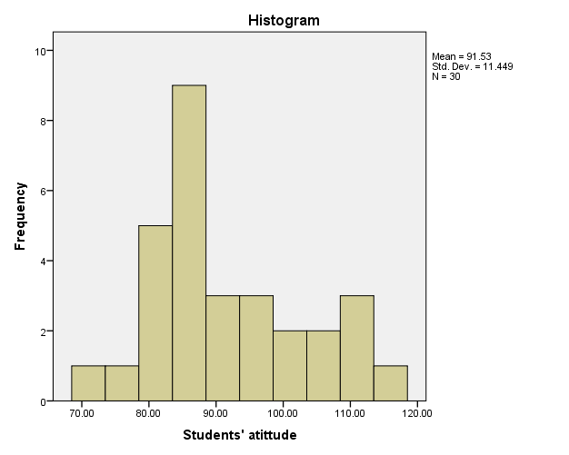

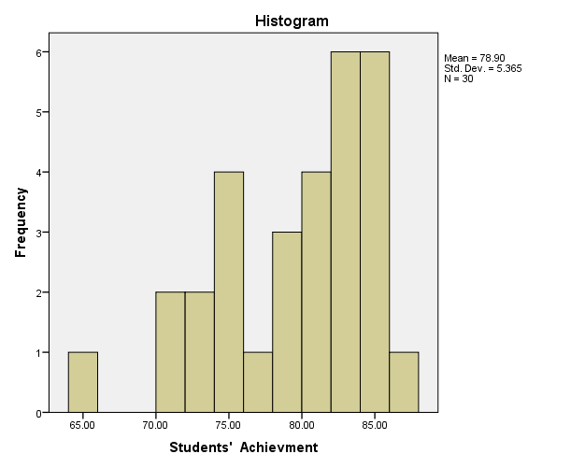

Appendix 6

Test of Linearity

Case Processing Summary
 | Cases
 | Included |  | Excluded |  | Total
 | N | Percent | N | Percent | N | Percent
Students' Achievment * Students' atittude | 30 | 100.0% | 0 | 0.0% | 30 | 100.0%

Report
Students' Achievment
Students' atittude | Mean | N | Std. Deviation
71.00 | 65.0000 | 1 | .
75.00 | 70.0000 | 1 | .
79.00 | 75.0000 | 2 | 4.24264
80.00 | 72.0000 | 1 | .
83.00 | 77.0000 | 2 | 4.24264
84.00 | 81.0000 | 2 | 2.82843
85.00 | 79.3333 | 3 | 4.04145
87.00 | 78.5000 | 2 | 4.94975
88.00 | 80.0000 | 2 | .00000
93.00 | 81.0000 | 3 | 5.19615
94.00 | 70.0000 | 1 | .
95.00 | 76.0000 | 1 | .
97.00 | 82.0000 | 1 | .
100.00 | 85.0000 | 1 | .
102.00 | 84.0000 | 1 | .
104.00 | 84.0000 | 1 | .
107.00 | 83.0000 | 1 | .
109.00 | 86.0000 | 1 | .
110.00 | 83.0000 | 1 | .
111.00 | 79.0000 | 1 | .
115.00 | 84.0000 | 1 | .
Total | 78.9000 | 30 | 5.36496

ANOVA Table
 |  |  |  | Sum of Squares | df | Mean Square | F | Sig.
 | Students' Achievment * Students' atittude | Between Groups | (Combined) | 679.533 | 20 | 33.977 | 1.971 | .148
 | Students' Achievment * Students' atittude | Between Groups | Linearity | 345.235 | 1 | 345.235 | 20.024 | .002
 | Students' Achievment * Students' atittude | Between Groups | Deviation from Linearity | 334.298 | 19 | 17.595 | 1.021 | .514
 | Students' Achievment * Students' atittude | Within Groups |  | 155.167 | 9 | 17.241
 | Students' Achievment * Students' atittude | Total |  | 834.700 | 29

Appendix 7
Surat Permohonan Izin Penelitian
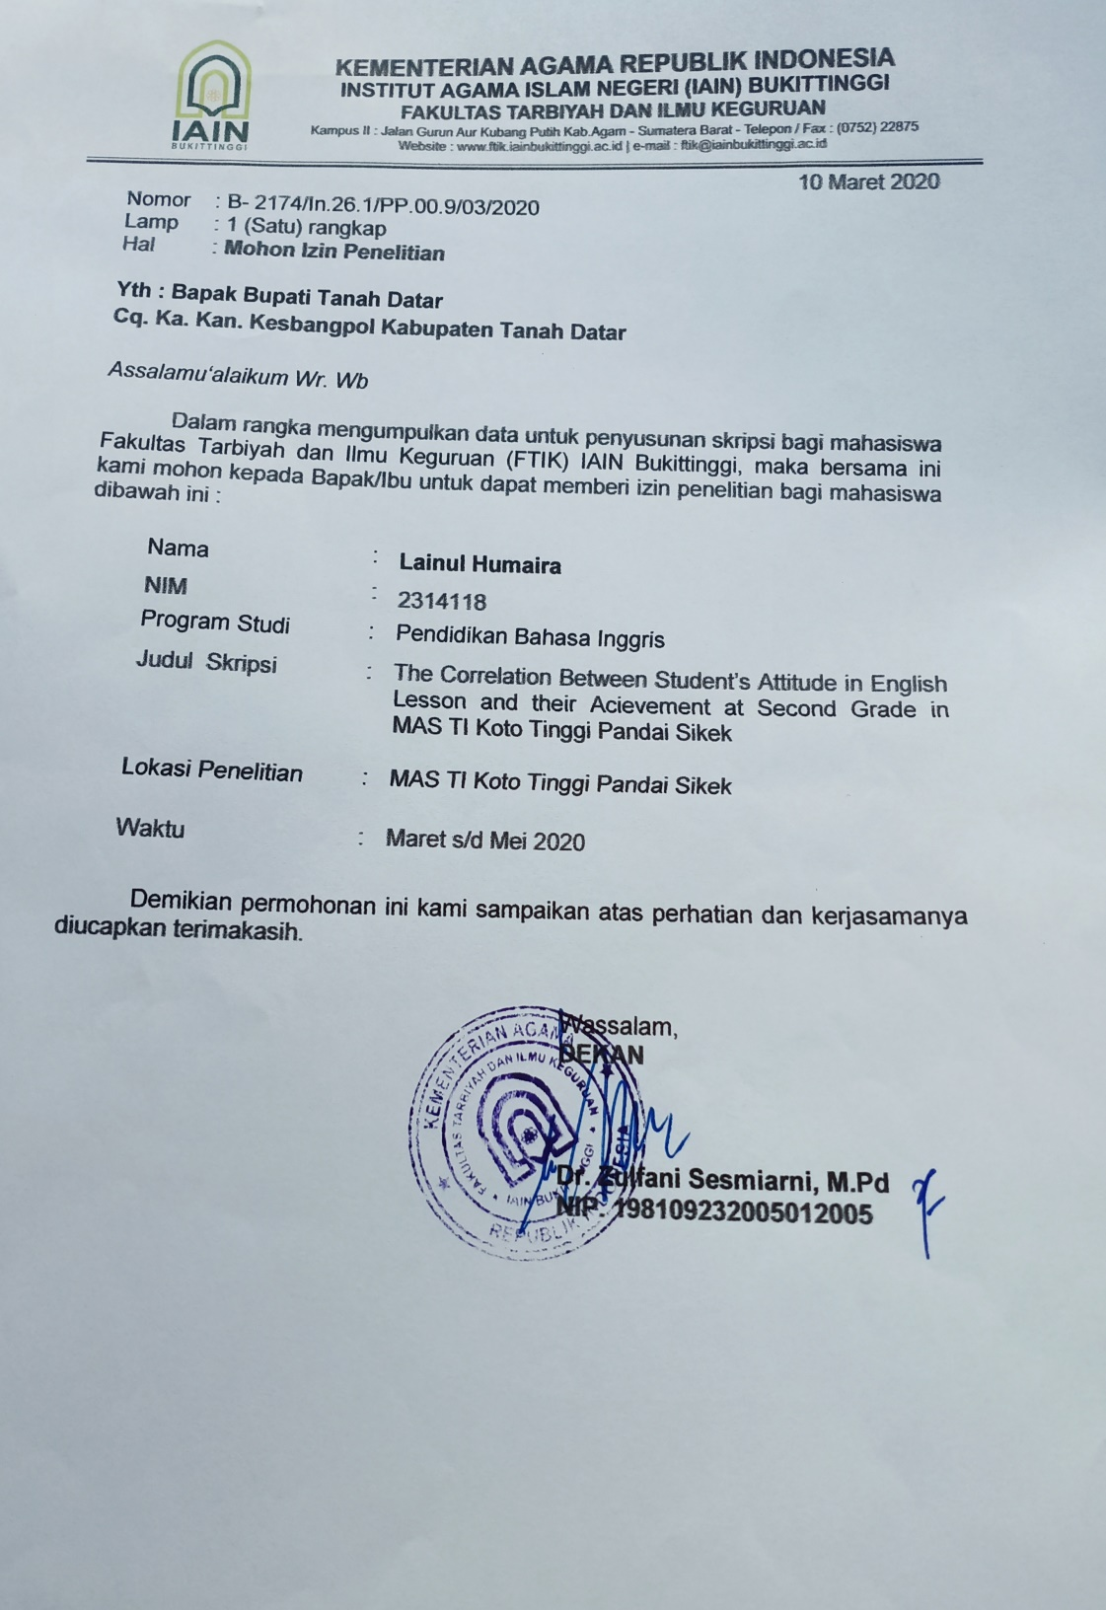

Appendix 8
Surat Izin Penelitian dari Kesbangpol
Appendix 9
Surat Permohonan Validasi
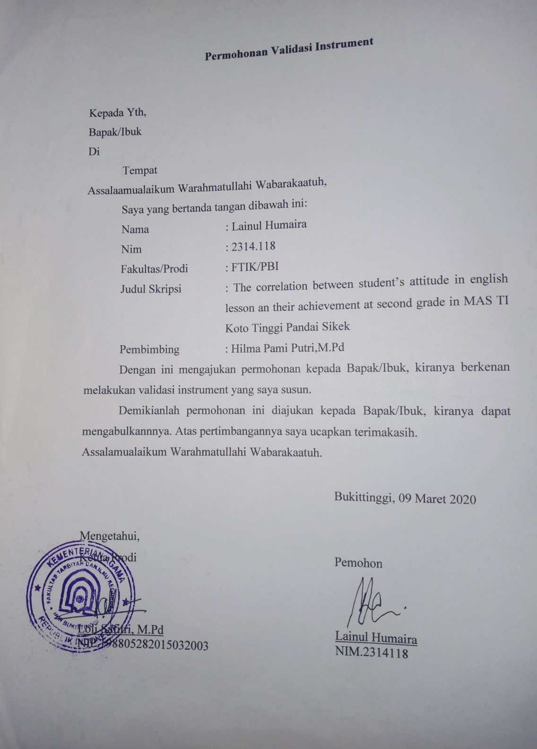

Appendix 10
Surat Pernyataan telah melakukan Validasi 1
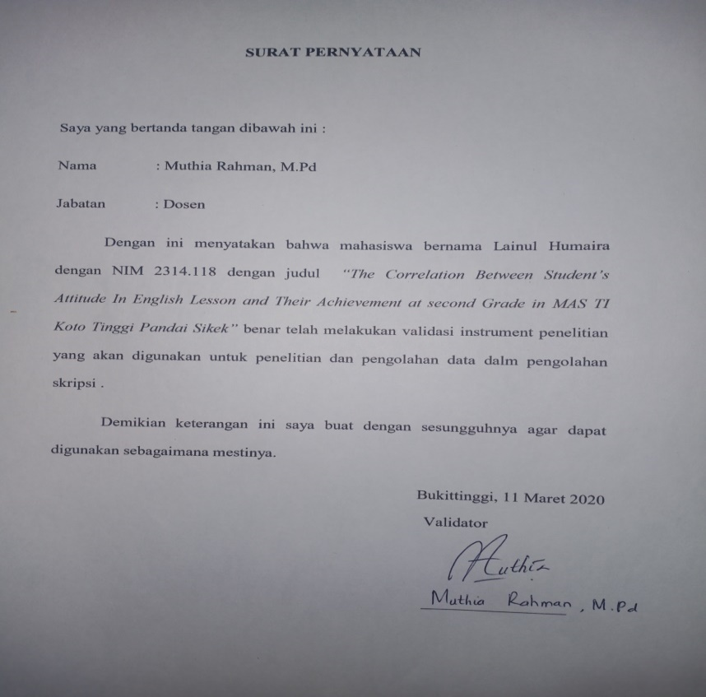
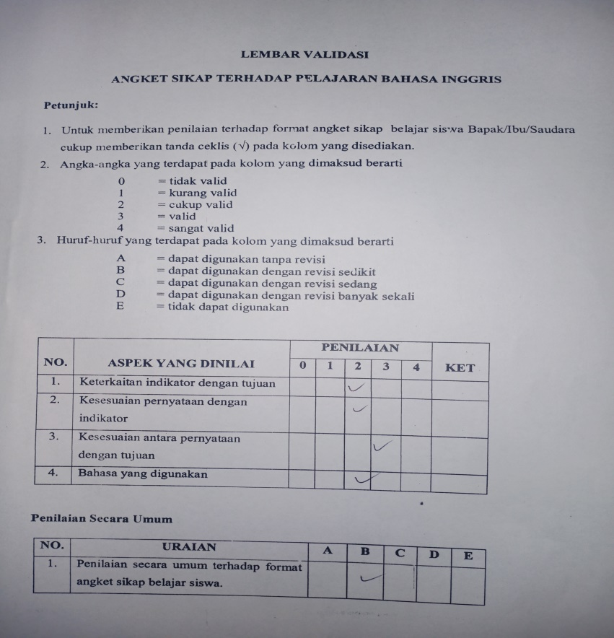
Appendix 11
Surat Pernyataan telah melakukan Validasi 2

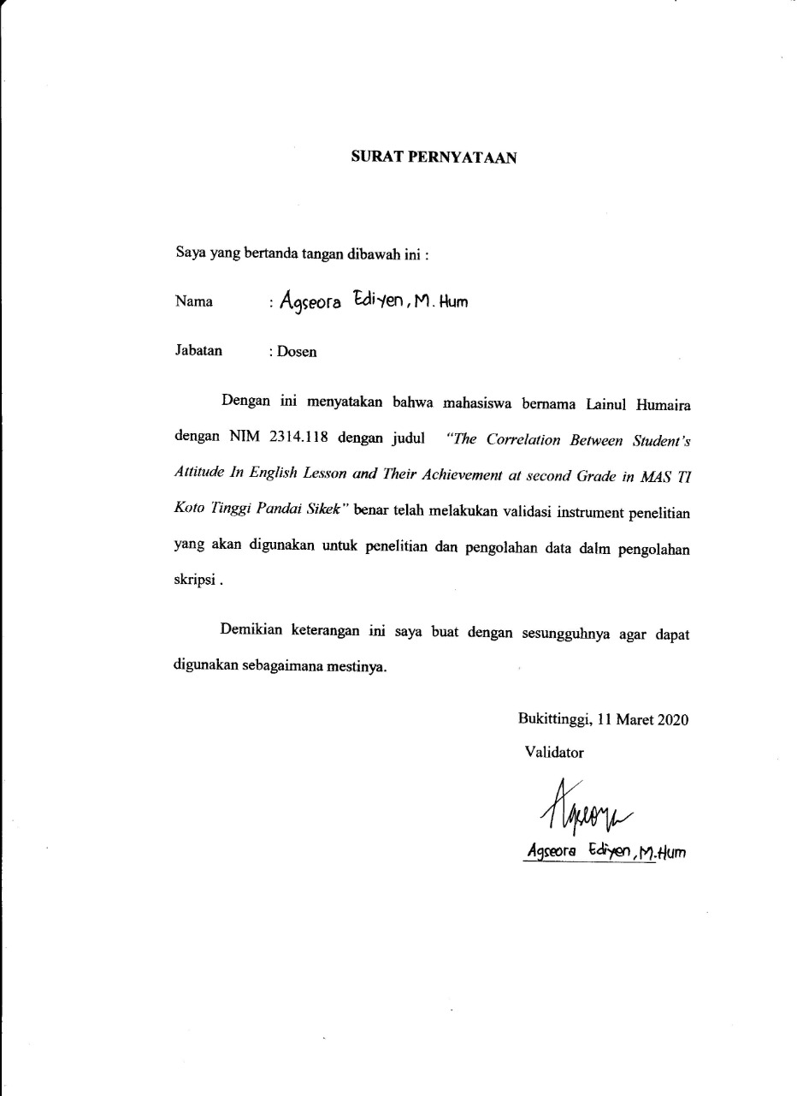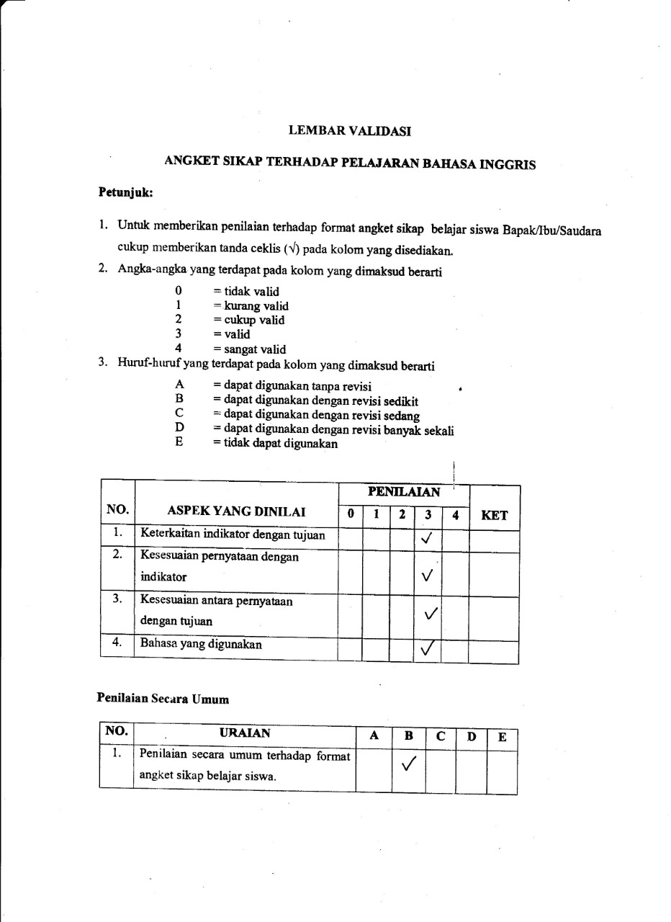
Appendix 12
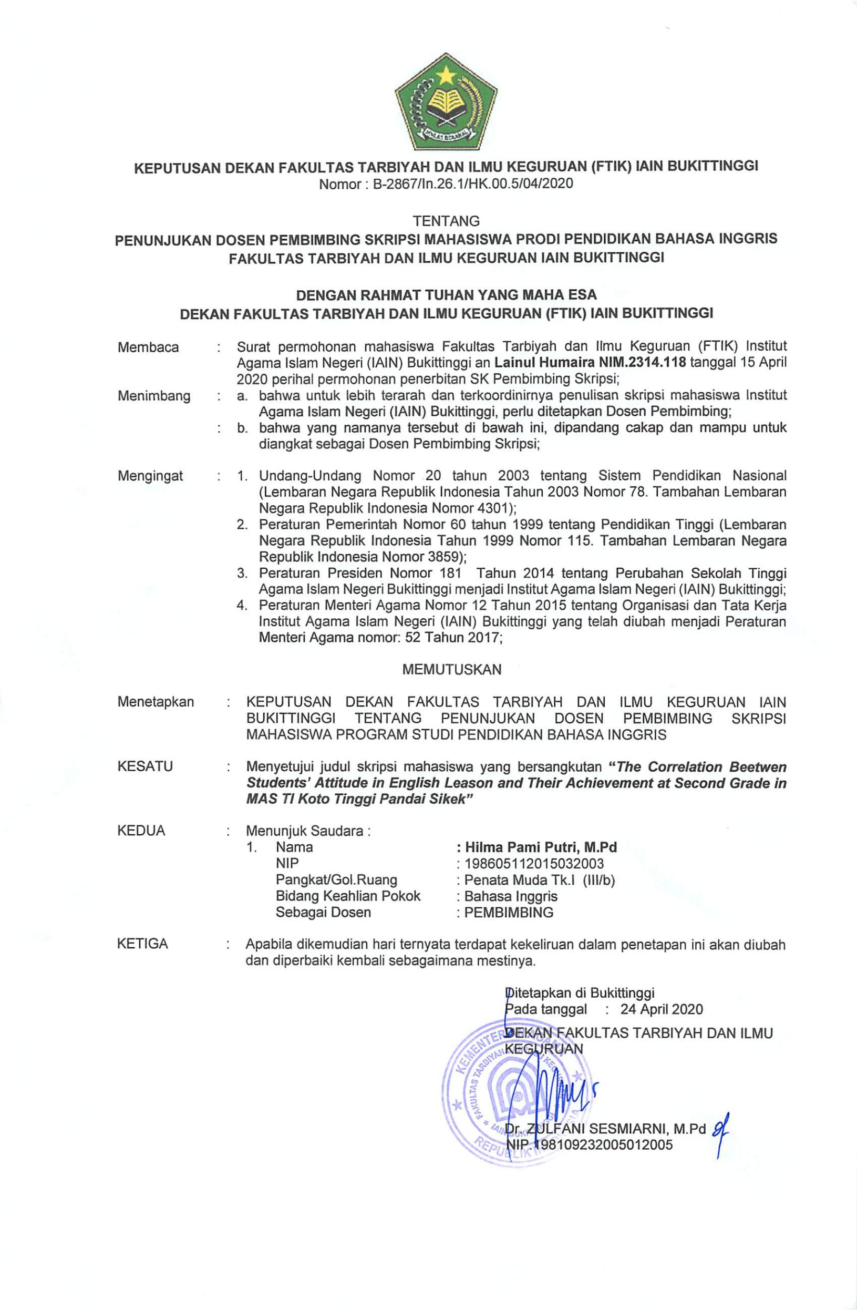
SK Pembimbing

Appendix 13
Nilai Rafor Bahasa Inggris siswa/i MAS TI Koto Tinggi
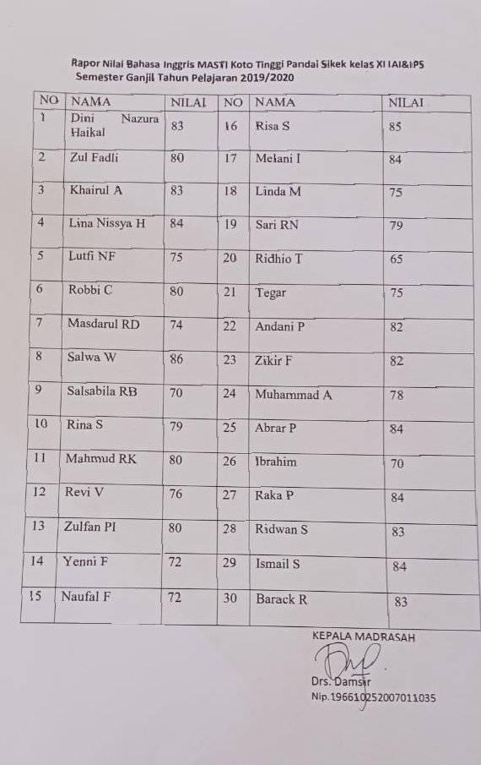

Saiful Sagala. 2011. Konsep dan makna pembelajaran. Bandung: Alfabeta
Dipdiknas RI.2006. Kurikulum pendidikan.
Aceng. 2017. Correlation between students’ attitude toward English and their English profeciecy. Lampung : Thesis, Unila p.23
English proficiency index 2006.
ibid
Suryabrata,Sumadi.1989.PsikologiPendidikan.Jakarta:CV.Rajawali. p.209
Gowhary.2015.relationship between attitude and speaking proficiency. Journal procedia social and behavioral sciences.p. 241
Op.cit aceng p.16
Davit and clerk. 2004. Manajemen strategi konsep-konsep. Jakarta : PT Indeks kelompok Gramedia p.6
SaifudinAzwar.2008. sikapmanusia; teoridanpengukurannya. Yogyakarta: PustakaPelajar. p.5
Gerungan.2004. psikologi social.Bandung : PT RefrikaAditama. p.160
Dimyatidan Mudjiono.2006.BelajardanPembelajaran.Jakarta : PT RinekeCipta. p.239
Rahmasari.2014. correlation between students’ attitude and their achievement in English. Thesis
Aceng. 2017. Correlation between students’ attitude toward English and their English profeciecy. Lampung : Thesis, Unila p.23
Op.citAzwar
N Mahmudah.2006.Hubungansikapsiswadalampembelajaran PAI terhadapprestasibelajar. Purwerejo : UMP.thesis.p.12
Bimowalgito. 2010. Pengantarpsikologiumum. Yogyakarta: PenerbitAndi. p.110
SuryabrataSumadi. Psikologipendidikan.Jakarta: PT. Raja Grafindopersada .2002
Op.citp.31-38
Sarlito and eko 2009 p. 152-154
Op.citGerungan. p.166-173
Rahmasari.2014. correlation between students’ attitude and their achievement in English. Thesis
Richard and Schmidt, 2010 . Teaching and applied linguistic. London : Pearson.p.206
SudirmandanHuzairin. 2017. SikapBahasaSiswa SMP dan SMA terhadappembelajaranBahasaInggris di Kota Bandar Lampung. Lampung: AKSARA JurnalBahasadanSastra Vol.18,No.1. P.44
ibid
TulusTu’u, 2004, PeranDisiplinPadaPerilakudanPrestasiSiswa, Jakarta: PT. GramediaWidiasarana Indonesia, , p. 115-116.
DimyantidanMudjiono, 2006, BelajardanPembelajaran, Jakarta: RinekaCipta, p. 3.
Ahmad Tafsir, 2003, MetodologiPengajaran Agama Islam, Bandung: RemajaRosdaKarya, p. 78.
MuhibbinSyah, 2000, PsikologiPendidikandenganPendekatanBaru, Bandung: RemajaRosdakarya, p. 132.
Slameto, 2003, BelajardanFaktor-faktor yang Mempengaruhinya, Jakarta: PT. RinekaCipta, h.188.
Djaali, 2009, PsikologiPendidikan, Jakarta: PT. BumiAksara, h. 115.
Nana Sukmadinata syaodih.2007. Metode penelitian pendidikan. Bandung : Rosdakarya p. 56
Tahzeh A. 2011. Metode penelitian praktis. Yogyakarta : Teras p. 63
Arifin 2008 p.28
Margono. Methodology penelitian pendidikan.(Jakarta: Rhineka Cipta. 2007). P.118
Loc.cit p.215
L.R Gay. Educational Research: competencies for analysis and application 6th editioan, new jersey: prentice Hall.2000. p.101
Margono, Metodelogi penelitian Pendidikan. Jakarta: Rhineka Ciota. 2005. P.121
Suharsimi Arikunto, Procedure Penelitian. Jakarta: Rhineka Cipta.1998.p.134
Sugiyono .2010.metode penelitian pendidikan pendekatan kuantitative ,kualitatif, dan R & D. Bandung : Alfabeta. P. 199
Kartini Kartono 1990. Pengantar Metodologi Riset Sosial. Bandung : Mandar Maju. P.200
Loc.cit
ibid
Nurul Zuriah. 2006. Metedologi penelitian social dan pendidikan teori aplikasi. Jakarta : Bumi Aksara. P. 191
Zainal Arifin. 2009. Evaluasi pembelajaran. Bandung : PT Remaja Rosdakarya. P. 169
Saifudin azwar .2008. sikap manusia; teori dan pengukurannya. Yogyakarta : Pustaka Belajar p.65
Arikunto. Prosedur penelitian suatu pendekatan praktik.2006.jakarta : Rineka Cipta P.178-179
ibid
Borich and kubiszyn.2015.Educational Testing and Measurement 11 th Edition.Wiley
ibid
Aceng. 2017. Correlation between students’ attitude toward English and their English profeciecy. Lampung : Thesis, Unila p.68

